AÇIKLAMALAR / REMARKS
- İngilizce yazılan cevaplarda hem İngilizcenin hem de ifadelerin teknik doğruluğu puanlanacaktır. - Please note that both English and the statement need to be correct to get points if you answer in English.
- Aşağıdaki 7 sorudan sadece 4 tanesini cevaplayınız. Her soru 25 puandır. Please answer only any 4 out of 7 questions below. Each question is 25 points.
- Kısa ve anlamlı cevap veriniz / Give short and expressive answers.

SORULAR / QUESTIONS
- Yönetim Bilişim Sisteminde karar seviyeleri nelerdir ? Bir banka için her seviyeye birer karar örneği veriniz. What are the decision levels for MIS ? Please give examples of each level for a bank.

Decision Level | Description | Example
Strategic | Competitive advantage, become a market leader. Long-term outlook. | Decide to begin mortgage funding
Tactical | Improving operations without restructuring the company. | To decide to use ATMs with another bank.
Operations | Day-to-day actions to keep the company functioning. | Opening a new accounts for new customers

- Destek işlevine göre bilişim sistemlerinin sınıflamasını şekil olarak gösteriniz. Şekilde ilgili bilişim sisteminde ilgili yönetici/çalışan sınıfı ve birer örnek uygulama verilmelidir. Please draw a figure to illustrate information systems classified by support function. Show manager/staff associated with each level and give an application example for each level.

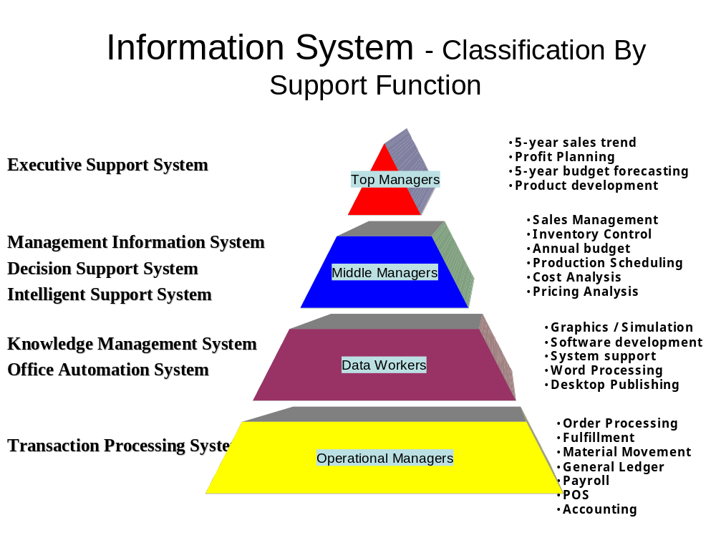

- Veri madenciliğini kısaca tarif ediniz / Please describe data mining briefly.

Data Mining is the discovery and extraction of hidden predictive information from large databases It uses statistical methods and artificial intelligence technology. Locates trends and patterns in data that would have been overlooked by normal database queries

- ERP (Kurumsal Kaynak Planlama) ’nin temel yazılım modüllerini ve işlevlerini maddeler halinde kısaca yazınız. Please list basic ERP software modules and their descriptions briefly.

ERP delivers a single database that contains all data for the software modules
- Manufacturing
  - Engineering, Bills of Material, Scheduling, Capacity, Workflow Management, Quality Control, Cost Management, Manufacturing Process, Manufacturing Projects, Manufacturing Flow
- Supply Chain Management
  - Inventory, Order Entry, Purchasing, Product Configurator, Supply Chain Planning, Supplier Scheduling, Inspection of goods, Claim Processing, Commission Calculation
- Financials
  - General Ledger, Cash Management, Accounts Payable, Accounts Receivable, Fixed Assets
- Projects
  - Costing, Billing, Time and Expense, Activity Management
- Human Resources
  - Human Resources, Payroll, Training, Time & Attendance, Benefits
- Customer Resources and Marketing
  - Sales and Marketing, Commissions, Service, Customer Contact and Call Center support
- Data Warehouse
  - and various Self-Service interfaces for Customers, Suppliers, and Employees

- Veri ve/veya erişim güvenliği ile ilgili iki yöntem yazınız ve birkaç cümle ile açıklayınız. Please list two methods for data/access security and describe them in few sentences.

Passwords are used for access security and authentication of the user. Password complexity, password aging, and minimum password lenght control are useful methods to build more secure passwords.

Security monitoring is a way of tracing security violations. It is performed by monitoring access logs and patterns. Therefore, security violations can be determined according to some predefined patterns. As a safeguard, you can apply lock-outs after certain times of failing logging attempts.

- Aşağıdaki iki tablodan hangi müşterinin (Isım) hangi malzemeyi (malzeme) sipariş ettiği sonucunu veren sorguyu SQL ile yazınız (JOIN kullanıp kullanmamak serbesttir). Write down the SQL that gives who (Isim) ordered what (malzeme) from the two tables below (you are free to use JOIN or not).

Musteri Siparis Sonuc Kümesi / Result Set
MusteriNo | Isim |  | UrunKod | Malzeme | MusteriNo |  | Isim | Malzeme
01 | Ali AK |  | 234 | Masa | 01 |  | Ali AK | Masa
02 | Mehmet KUZU |  | 657 | Abajur | 03 |  | Ayse DEMIR | Abajur
03 | Ayse DEMIR |  | 865 | Koltuk | 03 |  | Ayse DEMIR | Koltuk
04 | Ahmet FENER |  | 234 | Masa | 02 |  | Mehmet KUZU | Masa

SELECT Musteri.Isim, Malzeme.Siparis FROM Musteri, Siparis WHERE Musteri.MusteriNo=Siparis.MusteriNo

SELECT Musteri.Isim, Siparis.Malzeme FROM Musteri INNER JOIN Siparis
ON Musteri.MusteriNo=Siparis.MusteriNo

- Aşağıdaki terim ve kısaltmaların anlamlarını birkaç cümle ile açıklayınız. Please write short descriptions for the acronyms and expressions below.

EDI / EVD : EDI is considered to be a technical representation of a business conversation between two entities, either internal or external. The EDI (Electronic Data Interchange) standards were designed to be independent of communication and software technologies.
EDI can be transmitted using any methodology agreed to by the sender and recipient.

Certificate Authority / Onay Kurumu : certification authority (CA) is an entity which issues digital certificates for use by other parties. It is an example of a trusted third party. CAs are characteristic of many public key infrastructure (PKI) schemes.

Encryption / Şifreleme : Encryption is a method to transmit data to a other party. Triple DES (Data Encryption Standard), AES (Advanced Encryption Standard) are some well-known algorithms for it.

Veritabanı Normalizasyonu / DB Norrmalization : Normalization is the process of decomposing unsatisfactory "bad" relations by breaking up their attributes into smaller relations.

Knowledge / Bilgi : Information that has been organized and processed to convey understanding, experience and expertise as they apply to a current problem or activity.

